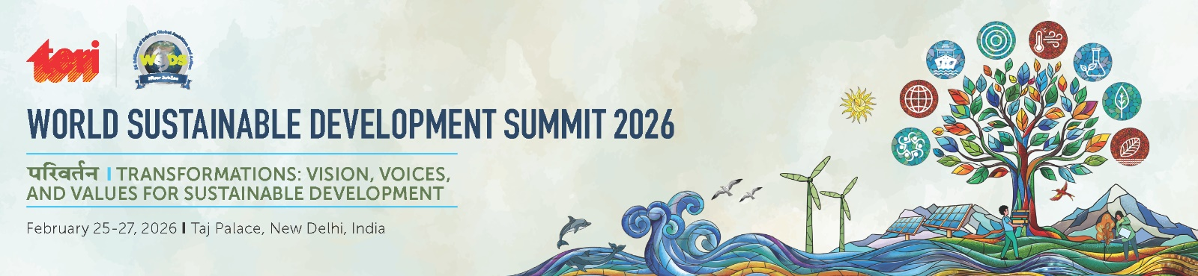

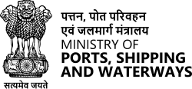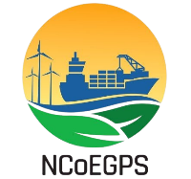

Title: Green Ports as a Gateway to Decarbonization
Date: 25th February 2026 (Wednesday)
Time: 2:00 pm to 3:30 pm (IST)
Venue: Mumtaz, Taj Palace, New Delhi

Time | Agenda Item (TBC)
1.00 p.m.- 2.00 p.m. | Lunch
2.00 p.m. - 2.05 p.m | Welcome Address  Shri R R Rashmi, Program Director, Green Shipping
2.05 p.m.- 2.15 p.m. | Thematic Address  Shri Shyam Jagannathan, IAS, DG of Shipping
2.15 p.m. - 2.25 p.m. | Keynote Address  Shri Vijay Kumar, IAS, Secretary, Ministry of Ports, Shipping and Waterways (MoPSW)
2.25 p.m. – 2.35 p.m. | Special Address  H.E. Marisa Gerards, Ambassador of the Kingdom of Netherlands to India , Nepal and Bhutan
2.35 p.m. - 3.20 p.m. | Panel Discussion / Roundtable  Speakers (TBC):  - Sh.Venkatesapathy S. JS (Port, IT & E-Gov), MoPSW  - Shri Vikas Narwal, Managing Director, India Port Association (IPA)  - Shri Amlan Bora, Chief Representative for Port of Rotterdam Authority in India, Sri Lanka and Bangalesh  - Representative from Mærsk Mc-Kinney Møller Center for Zero Carbon Shipping  - Shri Subrat Tripathy, Chairman, Adani Ports & SEZ  Moderator:  Mr Guilhem Gaillarde, Head of Ships Department, MARIN, Netherlands
3.20 p.m. - 3.25 p.m. | Question and Answer
3.25 p.m. - 3.30 p.m. | Concluding remarks  NCoEGPS Team
3.30 p.m.- 4.00 p.m. | Evening Tea

